Certainly! **PHP** is an open-source server-side scripting language widely used for web development. [It’s versatile, allowing you to create dynamic and interactive web pages, as well as build other projects, including Graphical User Interfaces (GUIs)](https://www.freecodecamp.org/news/what-is-php-the-php-programming-language-meaning-explained/) [1](https://www.freecodecamp.org/news/what-is-php-the-php-programming-language-meaning-explained/)[2](https://www.php.net/manual/en/intro-whatis.php).

Here are **five free reference links** where you can learn PHP:





1. [**W3Schools PHP Tutorial**](https://www.w3schools.com/php/): W3Schools offers an easy-to-follow tutorial with examples, exercises, and a quiz to track your progress [3](https://www.w3schools.com/php/).
2. [**Learn-PHP.org**](https://www.learn-php.org/): This interactive tutorial is suitable for both beginners and experienced programmers [4](https://www.learn-php.org/).
3. [**Kinsta’s List of Free PHP Tutorials**](https://kinsta.com/blog/php-tutorials/): Explore various free resources to enhance your PHP skills [5](https://kinsta.com/blog/php-tutorials/).

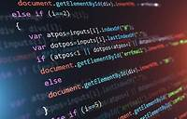

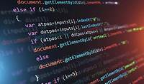

1. [**PHP Manual**](https://www.php.net/manual/en/intro-whatis.php): The official PHP manual provides detailed information on PHP functions, keywords, and constants [2](https://www.php.net/manual/en/intro-whatis.php).

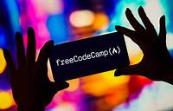

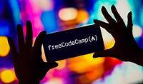

1. [**FreeCodeCamp: What is PHP?**](https://www.freecodecamp.org/news/what-is-php-the-php-programming-language-meaning-explained/): Learn about PHP’s history, advantages, and its use by companies like Facebook and Wikipedia [1](https://www.freecodecamp.org/news/what-is-php-the-php-programming-language-meaning-explained/).

Happy learning! 🚀👩‍💻